(D1) critically compare the OSI seven layer model and the TCP/IP model
The illustration below shows the 7 layer and 5 layer OSI Models
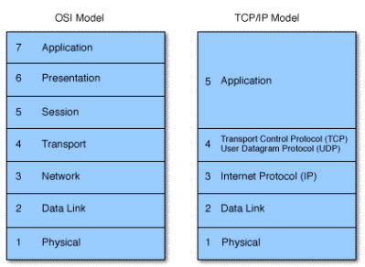
The Application, Presentation and Session layers are known as the Upper Layers and are implemented in software and as you can see they are combined under the title ‘Application’ in the 5 layer system.

The Transport and Network layer are mainly concerned with protocols for delivery and routing of packets and are implemented in software as well. The Data Link is implemented in hardware and software and the Physical layer is implemented in hardware only, hence its name. These lower two layers define LAN and WAN specifications.
5. the Application, Presentation and Session layer take user input and converts it into data
4. the Transport layer adds a segment header converting the data into segments
3. the Network layer adds a network header and converts the segments into packets / datagrams
2. the Data Link layer adds a frame header converting the packets/datagrams into frames
1. the MAC sub-layer converts the frames into a bits, which the Physical layer can put on the wire
The steps are known as the 5 steps of data encapsulation. When the bits stream arrives at the destination, the Physical layer takes it and converts it into frames, each layer will remove their corresponding header while the data flows up the OSI model until it is converted back to data and presented to the user. This is also known as decapsulation.
Research:
Comment:

